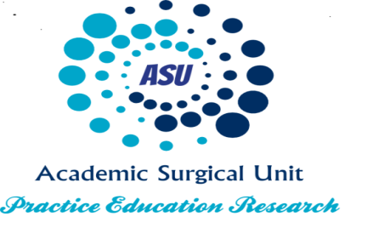
One day Laparoscopy /Suturing Course for Foundation Trainees
The Education Centre, CIC
21st June 2018
Course organisers: Professor R Canelo, Mr S Rehman and Mr S Ahmed
Course Programme

08.00 – 08.30 Welcome Prof R Canelo
08.30 – 10.30 Suturing Techniques, Material and Practice Mr S Rehman
10.30 – 11.00 BREAK
11.00 – 12.45 Bowel Anastomosis Techniques and Practice Mr S Ahmed
12.45 – 13.30 LUNCH
13.30 – 14.30 Vascular Anastomosis Techniques and Practice A Ranathunga
14.30 – 16.30 Laparoscopy Technique and Practice Mr S Rehman
16:30- 17.00 Close/ Feedback

NB This course will be credited 6 CPD points. The fee for foundation trainees is £20.00.
Please contact Bridget Hamilton to register for the course at bridget.hamilton@ncuh.nhs.uk

There are only 15 places available so please book early to avoid disappointment.

